U18CO018

Shubham Shekhaliya

Subject – DA

Assignment - 1

**Execute all commands on Linux terminal and note down the functionality of each.**

**(1) Basic Unix/Linux commands:**

ls, date, help, info, man, who, pwd, cat, more, mv, rm, chmod,

whoami,logout,wc,grep,sort,mkdir,rmdir,cd,tail,cmp,diff,cp,clear,df,du,uname,aptget,find,wget,top,mpstate,netstat,sar

**(2) Linux commands related with process:**

ps, kill, background processing (with &)

1. Ls - lists all files of current directory

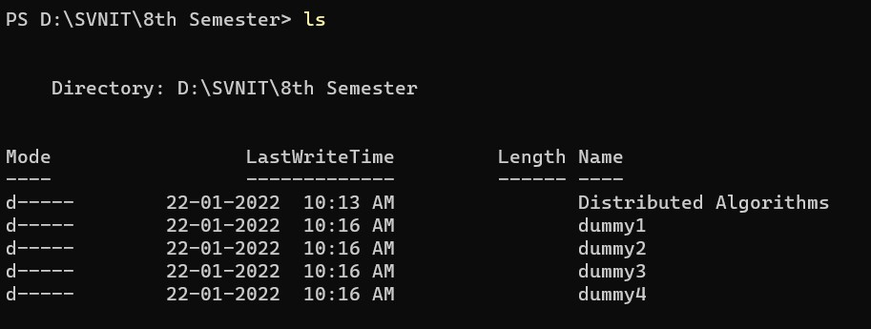

1. date - print or set the system date and time

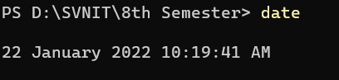

1. Man - an interface to the system reference manuals

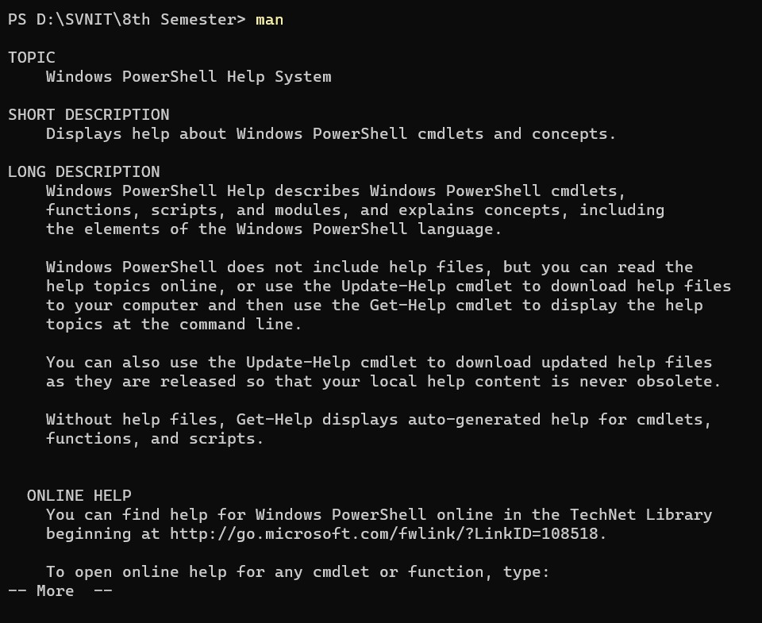

1. Who - show who is logged on
2. pwd-Print name of current/working directory.

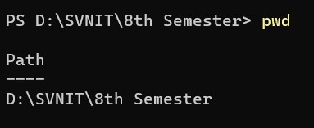

1. Cat-Print and concatenate files.

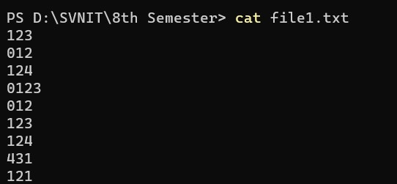

1. More-Open a file for interactive reading, allowing scrolling and search(in forward direction only).

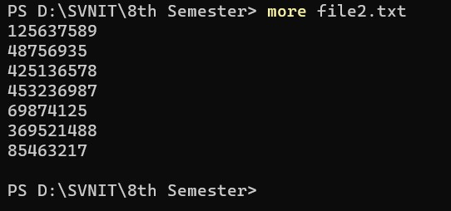

1. Mv - Move or rename files and directories.

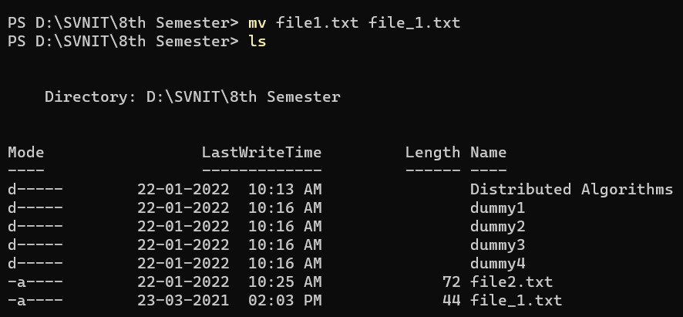

1. rm - Remove files or directories

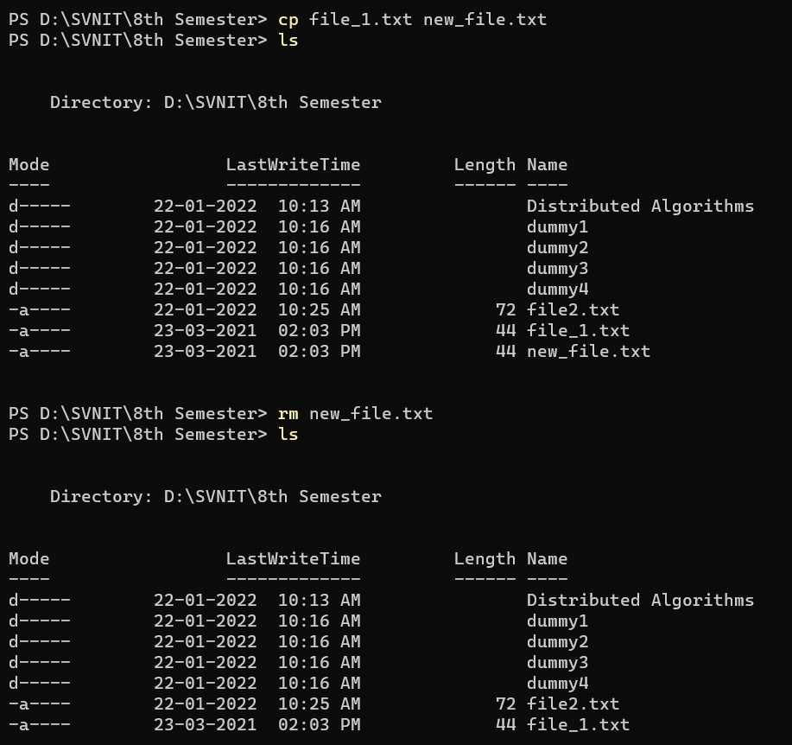

1. chmod-Change the access permissions of a file or directory.

Eg. Give the [u]ser rights to [r]ead and [w]rite to a file/directory: chmod u+rw {{file_or_directory}}

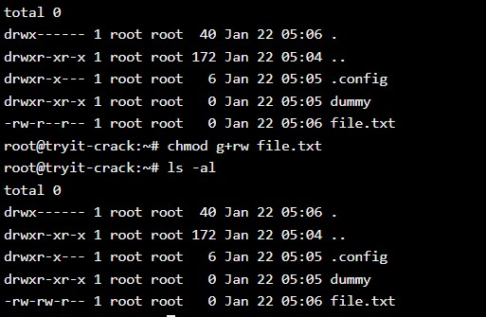

1. Whoami - Print the username associated with the current effective user ID.



1. Logout - logout command allows you to programmatically logout from your session. causes the session manager to take the requested action immediately.

$ logout

- User gets logged out

1. wc - Count lines, words, or bytes.

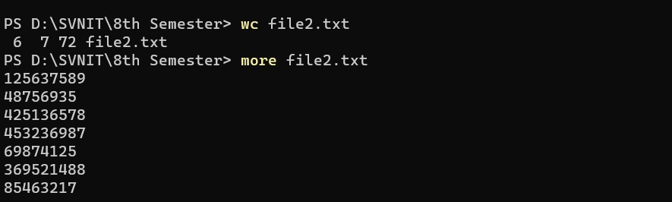

1. Grep - Matches patterns in input text. Supports simple patterns and regular expressions.

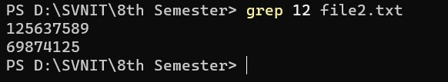

1. Sort - Sort lines of text files.

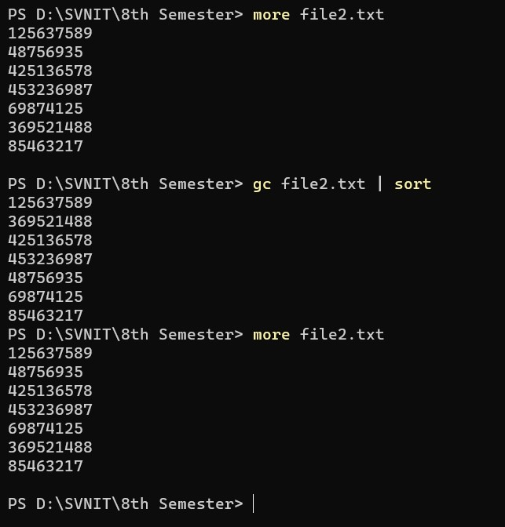

1. Mkdir - make directory

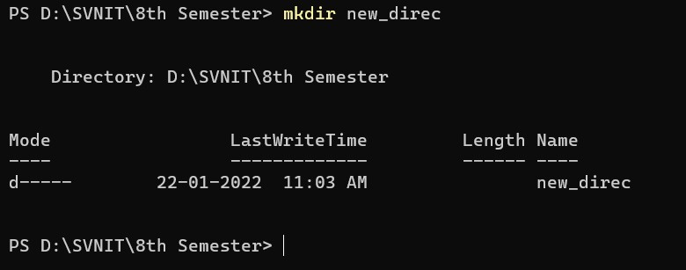

1. Rmdir - delete empty directory

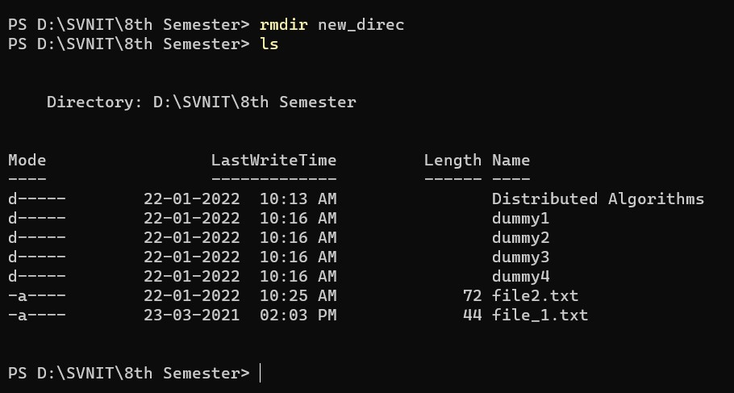

1. cd - change directory

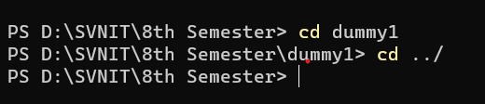

1. tail - Display the last part of a file.

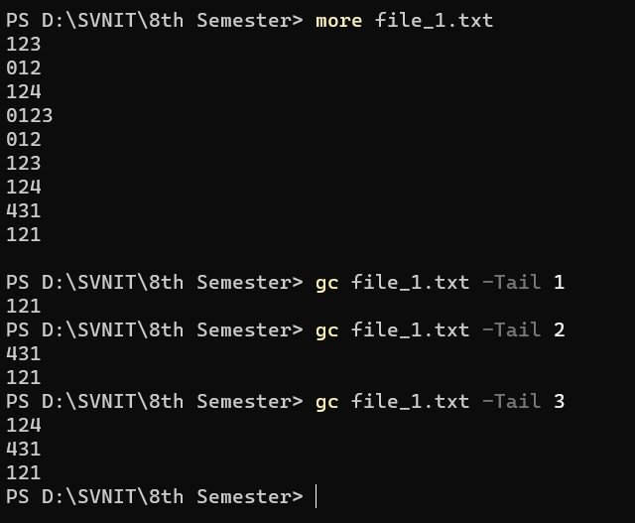

1. diff - Compare files and directories.

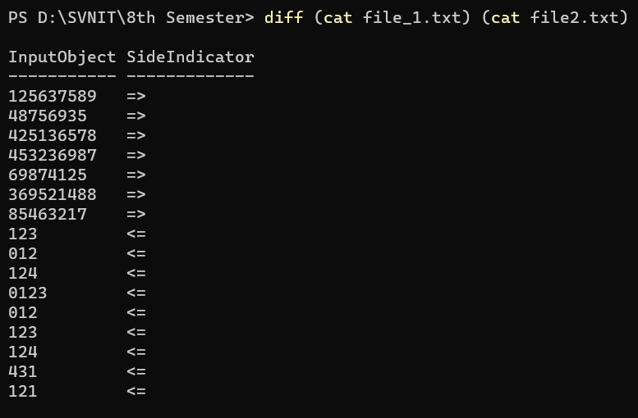

1. cmp - Compare two files.

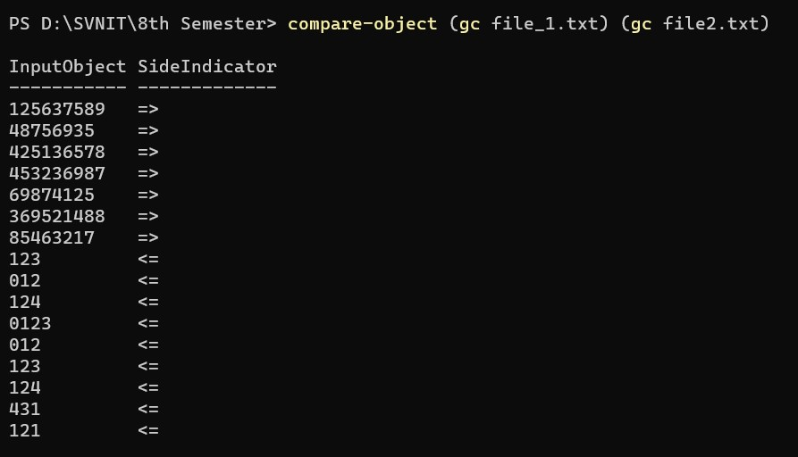

1. cp - Copy files and directories.

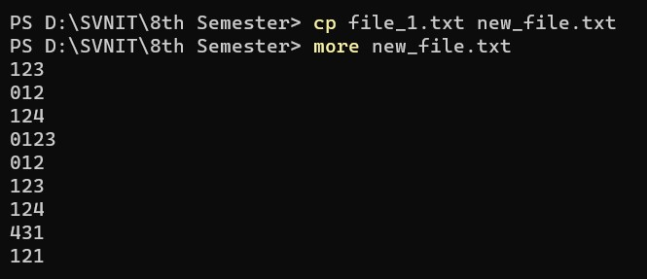

1. Clear - clear screen of terminal

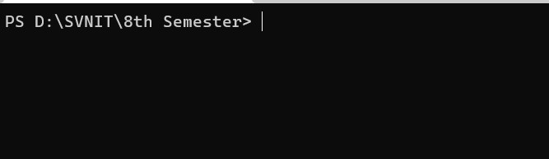

1. Du - Disk usage: estimate and summarize file and directory space usage. Disk usage of files in 8th Semester folder in KB and MB is shown below.

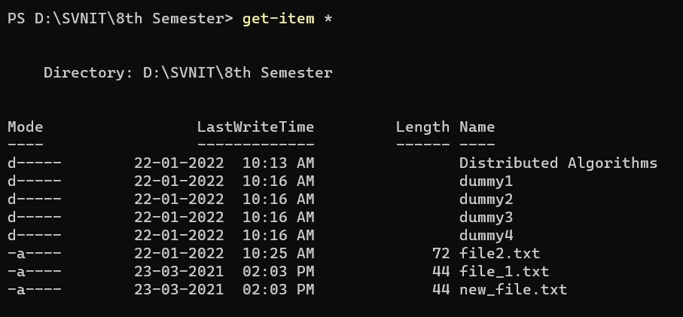

1. apt-get - Debian and Ubuntu package management utility. Search for packages using apt-cache.
2. uname - Print details about the current machine and the operating system running on it.

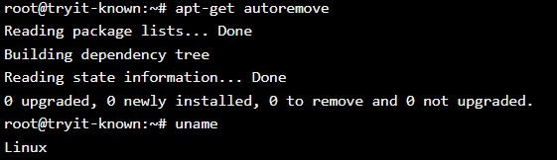

1. df - Gives an overview of the file system disk space usage.

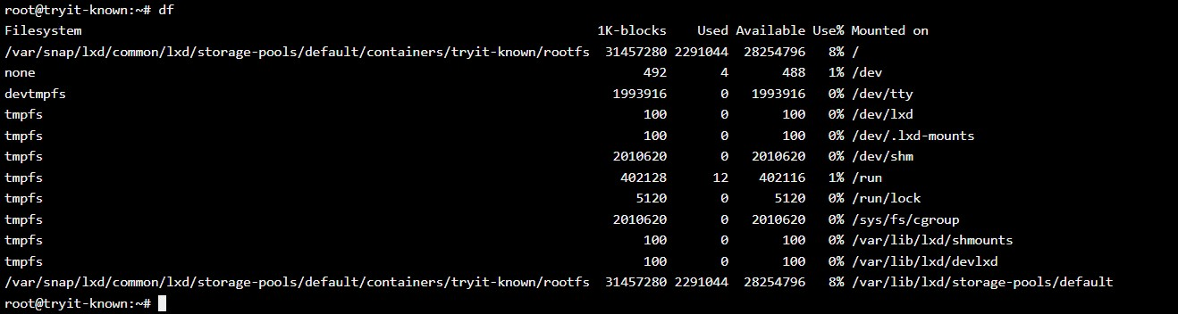

1. find - Find files or directories under the given directory tree, recursively

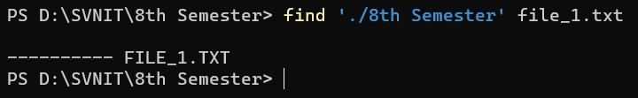

1. wget - Download files from the Web.Supports HTTP, HTTPS, and FTP.

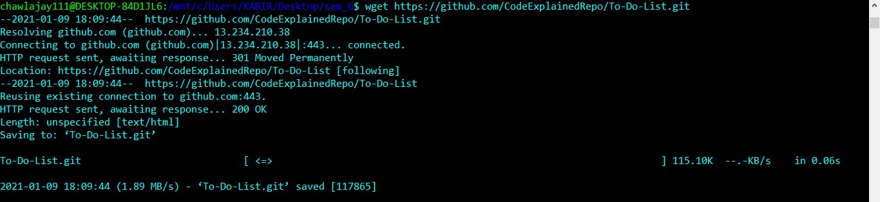

1. Top - Display dynamic real-time information about running processes

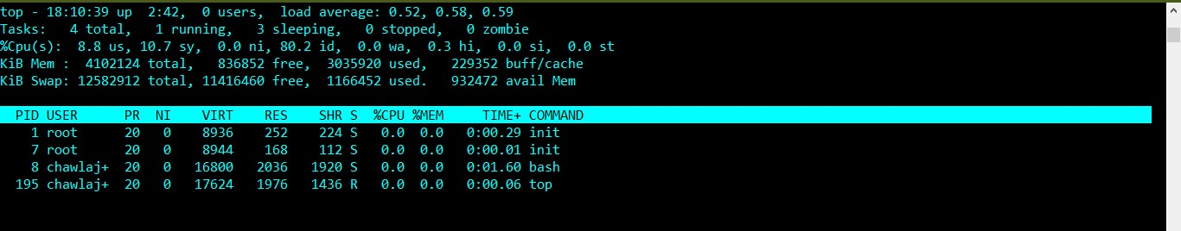

1. Mpstat - Report CPU statistics.



1. netstat - Displays network-related information such as open connections, open socket ports, etc.

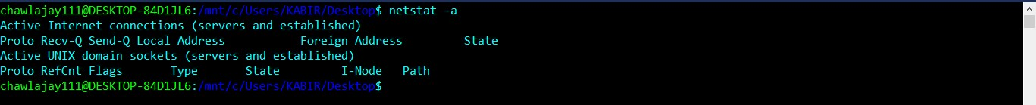

1. sar - Monitor performance of various Linux subsystems

Displays performance every 10 seconds

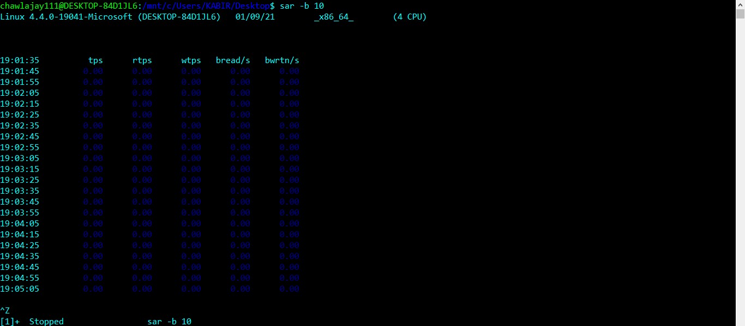

**Q2.**

1. Ps - Information about running processes.

Eg. ps aux lists all processes.

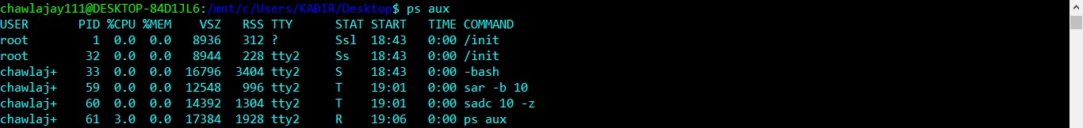

1. Kill - Sends a signal to a process, usually related to stopping the process.All signals except for SIGKILL and SIGSTOP can be intercepted by the process to perform a clean exit.



1. Background processes with & -> moves the process to background

Eg. Sleep command is moved to background using & and then using fg we bring it to foreground and we get a delay of 5 seconds.

